

The ArrayList class was added to the Java Collections Framework with the release of Java 1.2. It provides you with essentially the same functionality as the original library’s Vector class. However, the Vector class supports concurrent programming; that is, it supports programs that have more than one active thread. A thread is a flow of control in a program. Advanced Java programs can have multiple control flows that execute simultaneously and interact with each other.

The support that is necessary to enable concurrent programming requires extra processing whenever a Vector method is invoked, even when we aren’t using multiple threads. The extra processing makes the Vector class a poor choice for use with single-threaded programs. For single-threaded programs, you should use the ArrayList class instead of the Vector class.
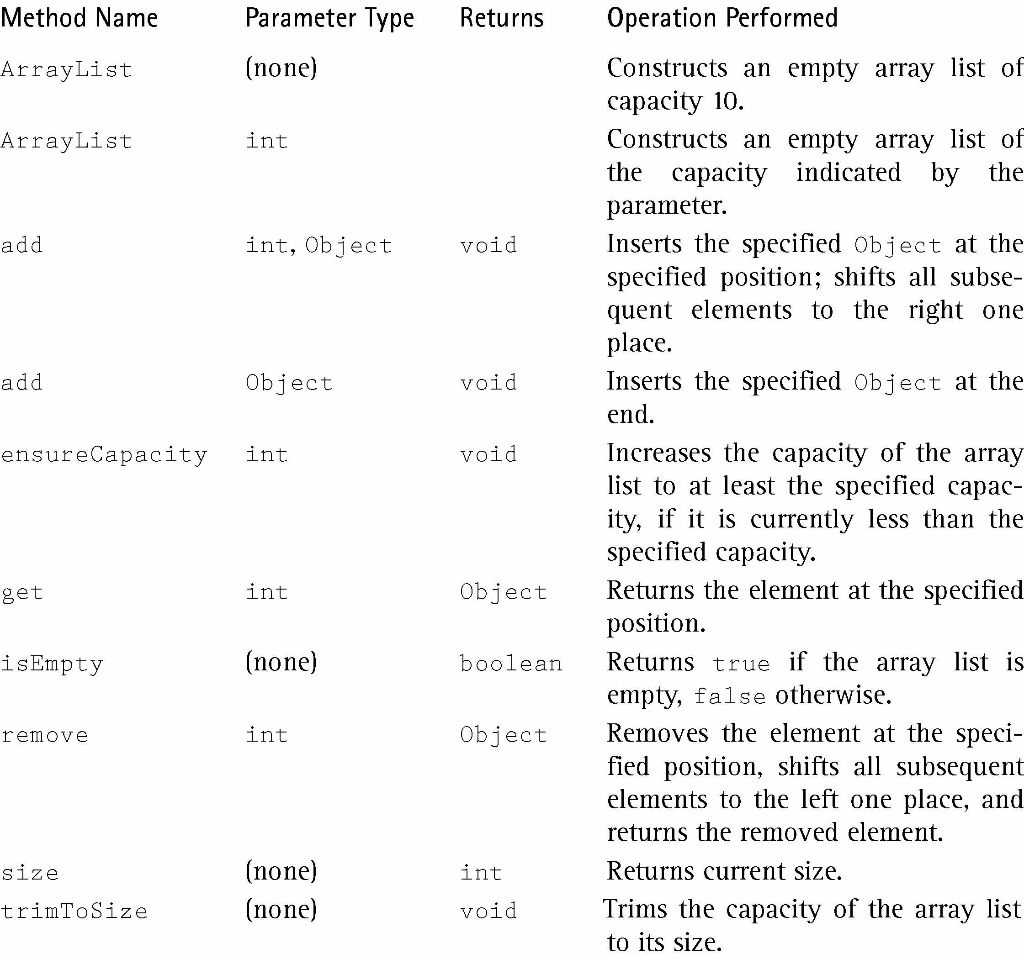

import java.util.*;
public class arrayList
{
public static void main(String[] args)
{
ArrayList a = new ArrayList(4);
a.add("NC");
a.add("SC");
a.add("GA");
a.add(2, "VA");
a.set(1, "TN");
a.remove(a.indexOf("VA"));
a.add("FL");
a.add(a.get(a.size()-1));

System.out.println(a.size());
for (int i = 0; i < a.size(); i++)
System.out.print(a.get(i) + " "); System.out.println();

Object[] myArray = a.toArray();
for (int i = 0; i < myArray.length; i++)
System.out.print(myArray[i]+ " ");
System.out.println();
}
}

Sample Run

5
NC TN GA FL FL
NC TN GA FL FL

